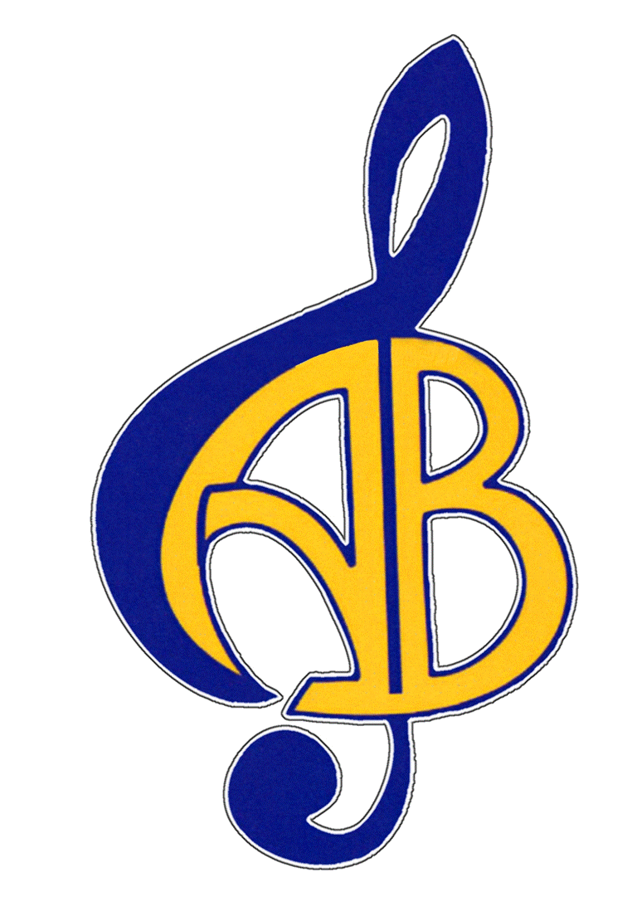
BECOME A MEMBER of the Acton Boxborough Friends of Music! As a non-profit organization, we are staffed completely by volunteers, and 100% of donations support the music programs in the school district. ABFOM funds help pay for:
Please Join Acton Boxborough
Friends of Music!!!
- musical events, special guest conductors and instruction
- equipment, uniforms, costumes, props, and supplies
- music scholarships for graduating seniors and students in grades 7-11
- event transportation… and much more.
Membership does not obligate you to volunteer, but your help is welcome! Please fill out the Volunteer Interest Survey at www.abfom.org to let us know how you would be interested in volunteering.
Only one membership donation per family is requested per school year, regardless of the number of siblings participating in band, color guard, or chorus.
To join Friends of Music, complete the information below and return this form with your check for $30 made payable to ABFOM. You can mail the form to ABFOM, PO Box 2334, Acton, MA 01720. Or you can return it with your other band forms to Mark Hickey or with any chorus forms to Jennifer Moss, ABRHS, 36 Charter Rd., Acton, MA 01720. Thank you for your support!
Check here if you’d like a free AB Music Department decal _____
(Please provide us the mailing address if it is not on your check.)
Parent / Guardian Name(s):_____________________________________
Contact Phone:_________________ Email: ________________________
Oldest Student Currently in the ABRHS Music Program:
- Name:_________________________________________
- Grade:________
- Participating in? Band__ Chorus__ Color Guard__ String Ensemble__
Basic 2017-2018 Dues $30.00
AB Music Magnets: Number____ x$5.00 $_____
Additional AB Music Decals: Number____ x$2.00 $_____
Optional additional contribution (any amount is appreciated) $_____
TOTAL $_____

