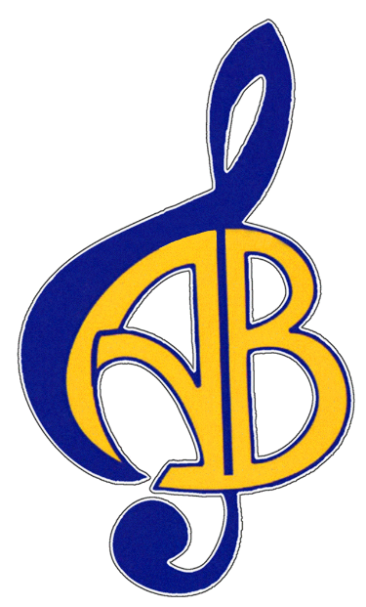

Dear (Grandma, Aunt/Uncle, Friend, etc..)

I have been accepted for membership in the Acton Boxborough Regional High School (ABRHS) Madrigal Singers/Women’s Ensemble/Concert Choir/Chamber Choir. It is quite an honor to be a part of this group. The members of our music group work extremely hard and strive to bring positive recognition to our school and our communities.

Our Choir will travel, and perform throughout the state of Massachusetts as well as participate in a larger national concert tour. The hours are long and the rehearsals are demanding, but the payoff is the excitement shown by audiences and the increased skill level I will achieve.

Participating in national and/or international musical events will cost members additional fees, ensuring coverage of travel, instructions, and equipment. This is where you can make a difference by offering your financial support. Any money you contribute on my behalf goes directly to sponsor me and offset my participation and travel fees.

The AB Friends of Music (ABFOM), which is the Parent Booster organization supporting the ABRHS Music Department, is a nonprofit organization dedicated to the performing arts education of young people in the towns of Acton and Boxborough. ABFOM also supports the choruses, string and band programs. They provide opportunities for the members of the music department to earn money through fund-raising events and accept donations on our behalf.

Your contribution will be considered a charitable donation and may even be tax deductible. Please consult your tax advisor and keep a copy for your records.

In order to ensure maximum benefit to me, please send the attached sponsorship form as soon as you can. Place my name on the form, but not on your check. Your check should be made out to ABFOM.

Thank you for your consideration!

Sincerely,

Jane/Joe Music student signature and name here.

2016-2017 Member
ABRHS Madrigal Singers/Women’s Ensemble/Concert Choir/Chamber Choir
www.abfom.org

Method of Payment:
ABFOM is a 501(c)3 tax-exempt organization.
Federal Tax ID#: 22-2814211
Cash
Check # ___________ (Payable to ABFOM)
Sponsor Signature ___________________________________
Amount Paid: ____________________
Date_________
My Company has a matching gift program:
Yes
No
Your donation may be tax deductible. Please consult your tax advisor and keep a copy for your records.
Student you wish to Sponsor: _______________________________________

